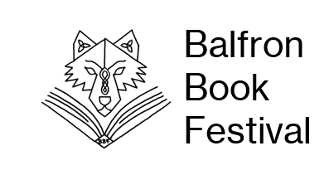
Balfron Book Trail Quiz
Solve the 20 clues at each of the Balfron Book Trail locations by scanning the QR Code and reading the book summary information.
Name:

Contact email/phone number:

1.Even ’who’ needs a haircut at Erhan’s Barbers?

2.What do the friends fight together to save at the Willow and the Olive Branch?

3.What do the characters found at the Balfron Co-op stop at the supermarket to buy?

4.Where will you be able to see the author found at Bakers and More on Saturday 6th September?

5.What board game pieces are mentioned in the book linked to Balfron Eyecare?

6.What job is the main character found at Balfron Post Office forced to take?

7.What non-human skeleton is one of the main characters hiding out at Strathkelvin Chiropractic?

8.Who is the toughest Tom in town that can be found ta the Hair Shop?

9.What is the name of the mysterious tribe at the heart of the story found at Gym63?

10.What is the name of the pet pig who lives at Base Pizza?
11.What tv show does the main character located at Balfron Pharmacy star in?

12.What book is the main character’s father working on at Balfron Library?

13.What is the main character afraid off at The Nest?

14.What is the name of the author working away at the Two Ravens Forge?

15.What is needed to end tyranny and restore peace at Borthwick and Forrest?

16.What is being taught how to make a proper cup of tea at the Pirn Inn?

17.Who is the chocolate maker extraordinaire at Lou’s Bake Stop?

18.Who is the unexpected visitor ringing the doorbell at Doyles Café?

19.In what ocean is the book found at Balfron Butchers set?

20. Who is the main character found at Nayland’s Hair Salon desperately in love with?

Once you have completed the quiz, you can be in with a chance to win some very special Balfron Book Festival goodies. To enter the prize draw, hand in your completed sheet at the Balfron Book Festival Headquarters which will be located on the Tontine corner across from the Post Office from Friday 5th September to Sunday 7th September – there may even be some treats on offer there for all finishers! Alternatively, you can hand it at any of the Balfron Book Festival events or email a photo of your completed entry to balfronbookfestival@gmail.com by 10th September.
